6. Create @app/controllers/AdhocValidationController . php as follows:

<?php

namespace app\controllers;

use app\components\WordsValidator;

use app\models\Article;

use yii\helpers\Html;

use yii\web\Controller;

class AdhocValidationController extends Controller {

private function getLongTitle()

'it should be

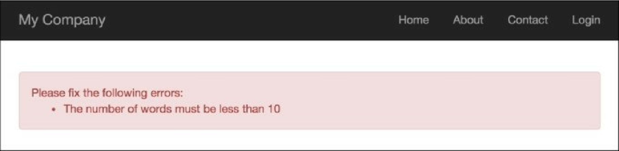

{

return 'There is a very long content for current article, less then ten words';

}

private function getShortTitle()

{

return 'There is a shot title';

}

private function renderContentByTitle($title)

{

$validator = new WordsValidator([

'size' => 10,

]);

if ($validator->validate($title, $error)) {

$content = Html::tag('div', 'Value is valid.',[ 'class' => 'alert alert-success',

]);

} else {

$content = Html::tag('div', $error, [

'class' => 'alert alert-danger',

]);

}

return $this->renderContent($content);

}

public function actionSuccess()

{

$title = $this->getShortTitle();

return $this->renderContentByTitle($title);

}

public function actionFailure()

{

$title = $this->getLongTitle();

return $this->renderContentByTitle($title);

}

}

7. Run the success action of the AdhocValidationController by opening the index.php?r=adhoc-